***Online Test Application-***

***All Pages Present on the github… Ex:-welcome page etc.***

***Home Page***

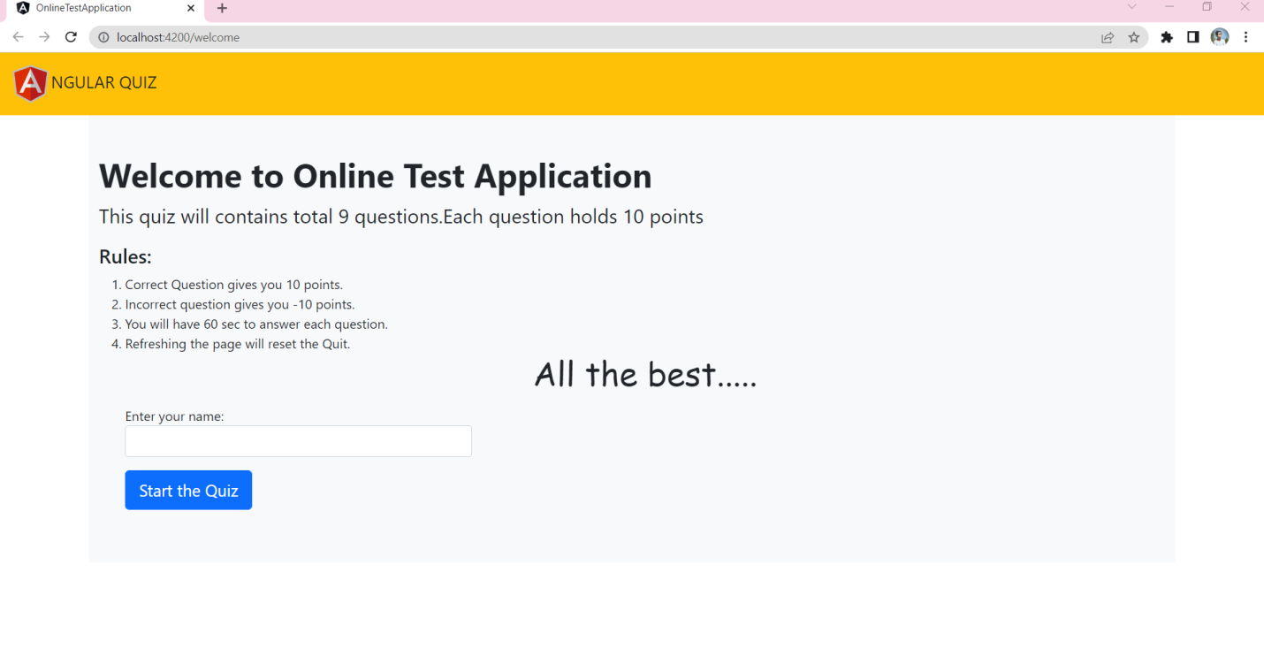

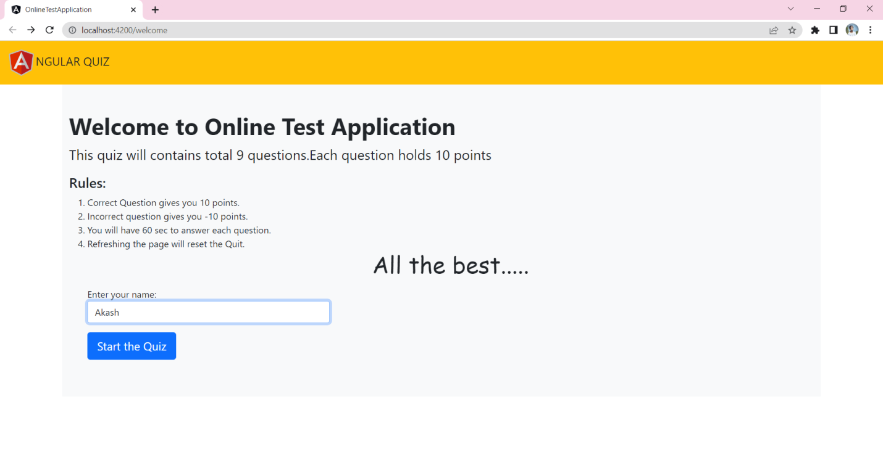

When you open a game first time it will be redirected to welcome page.

On clicking the button background-color will change automatically.

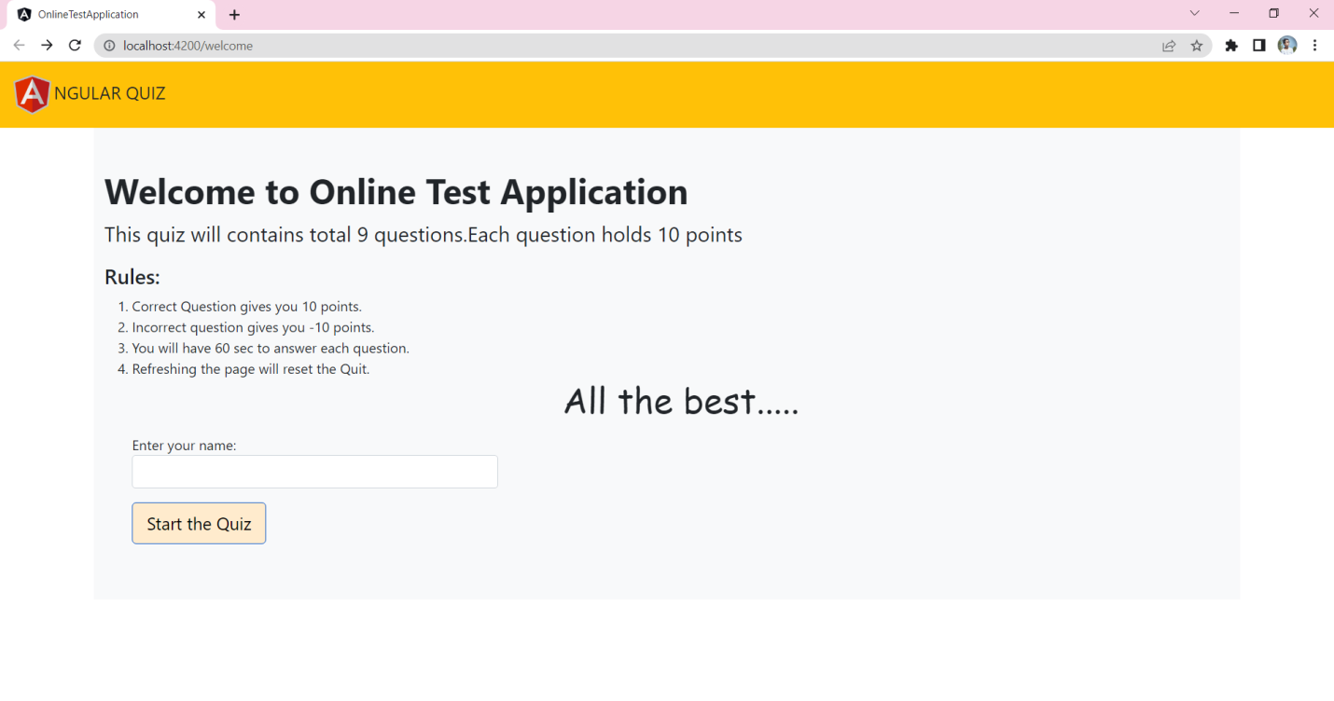

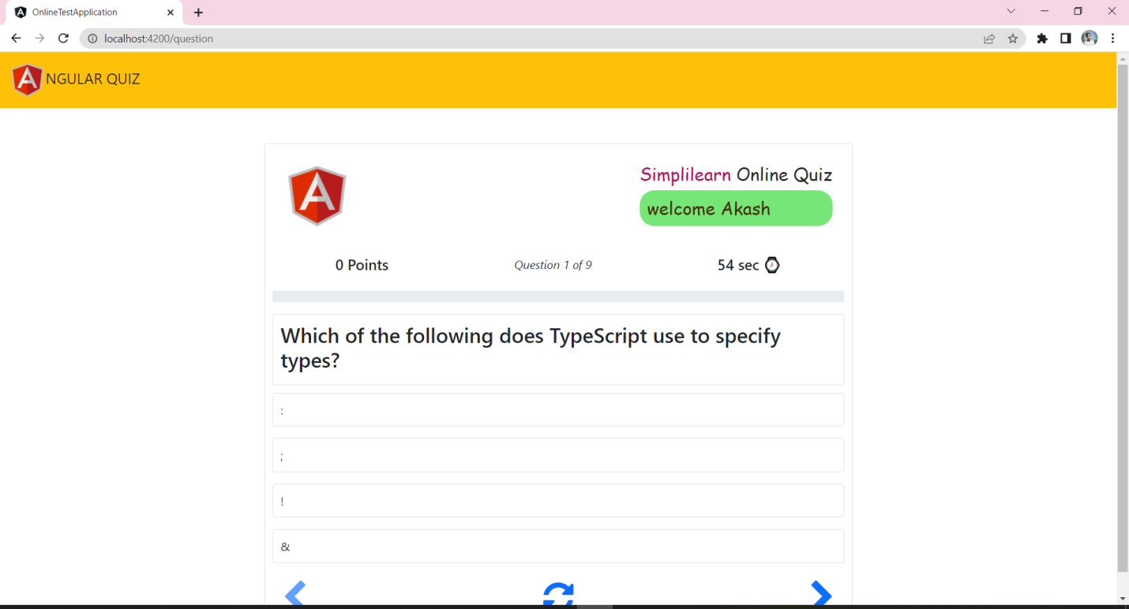

On clicking start the quiz page changes and redirect to question page.

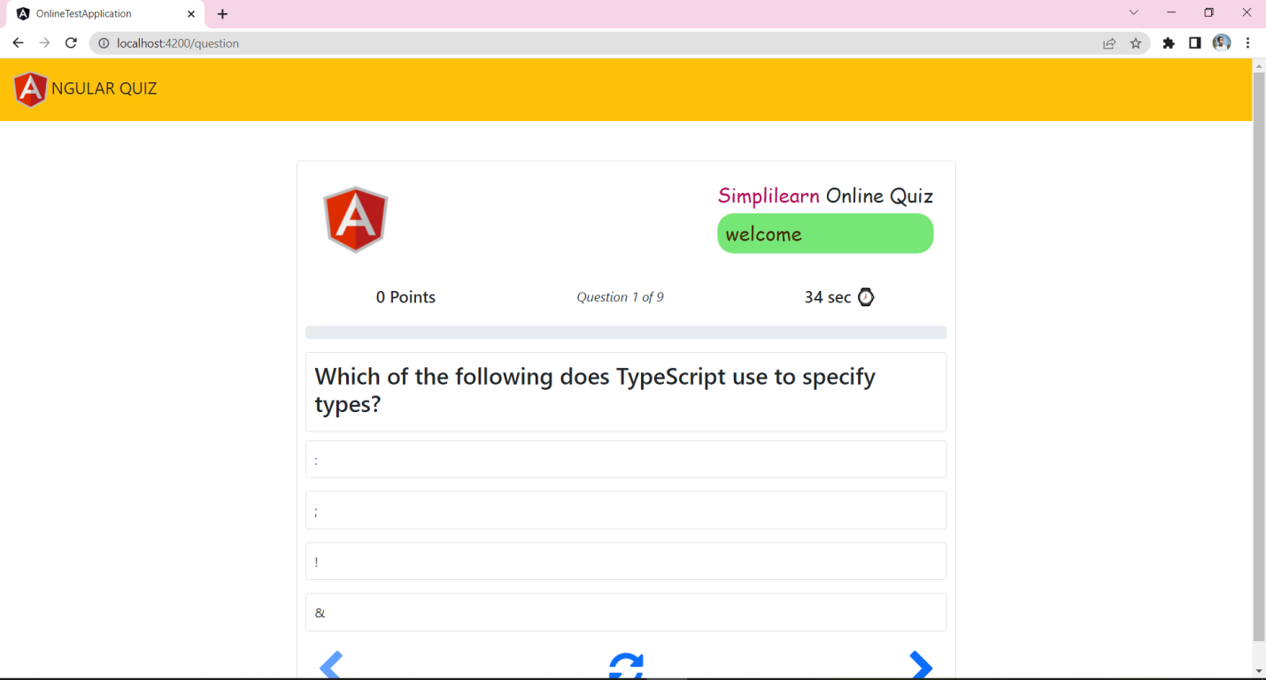

Time will be automatically decreases every sec the total time/que. Is 60 sec.

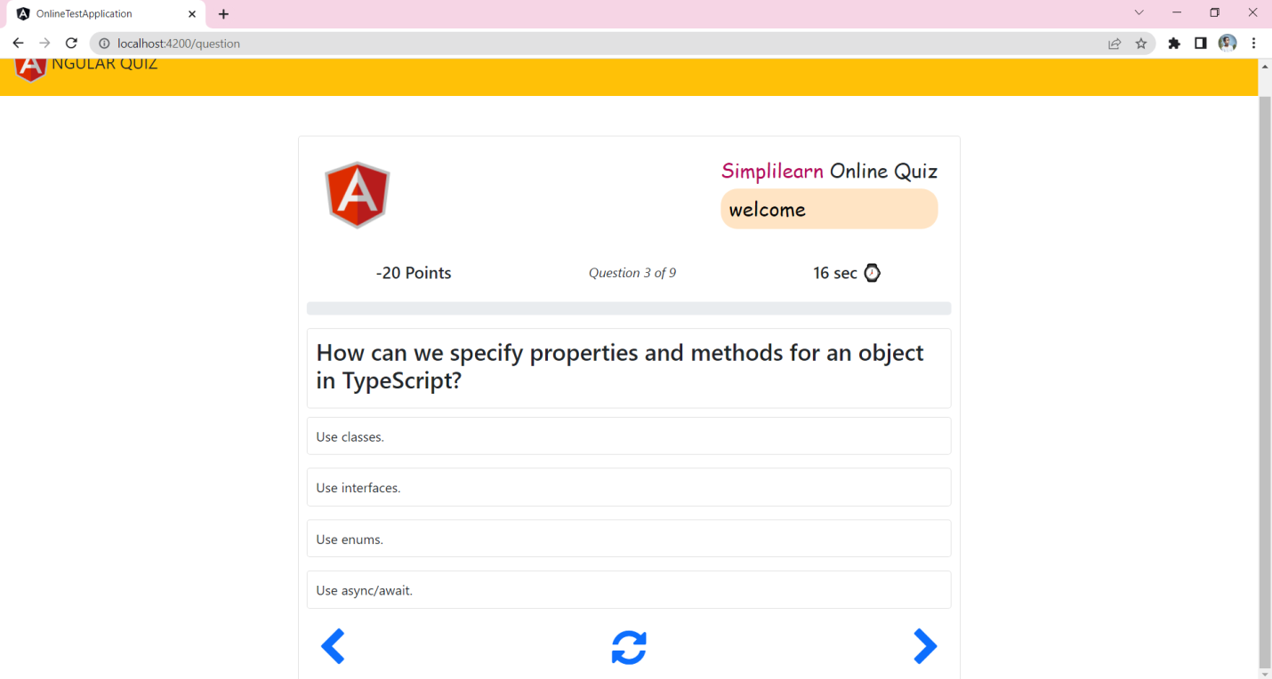

On every correct answer the green color indicates your choice is right

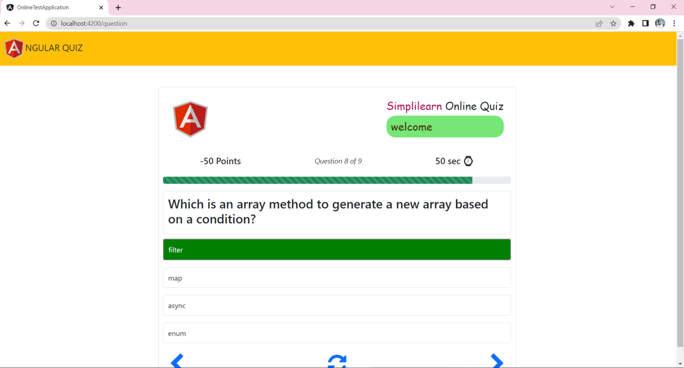



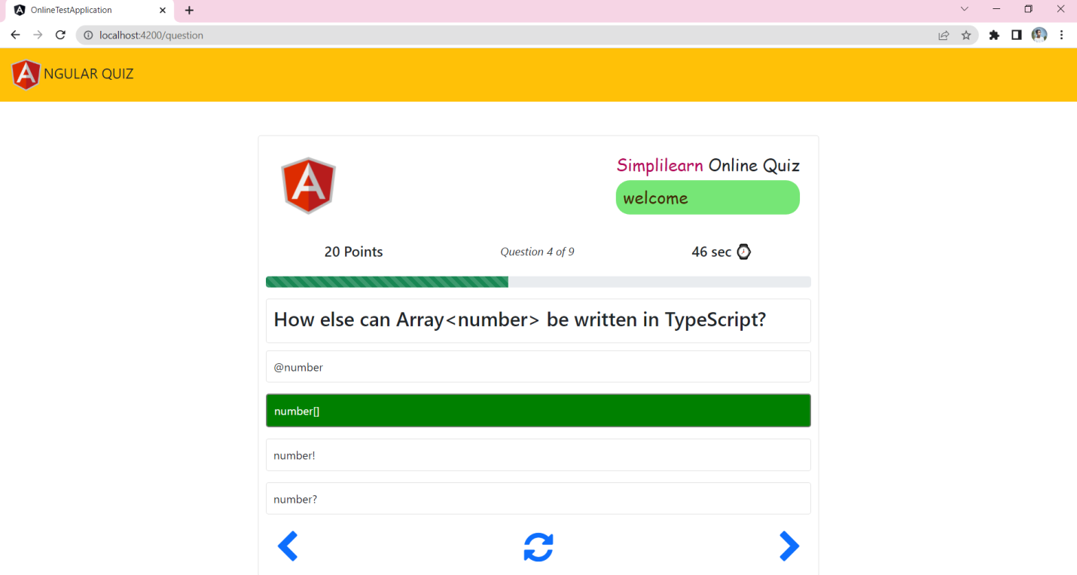

And on every wrong answer the green color indicates your choice is wrong.

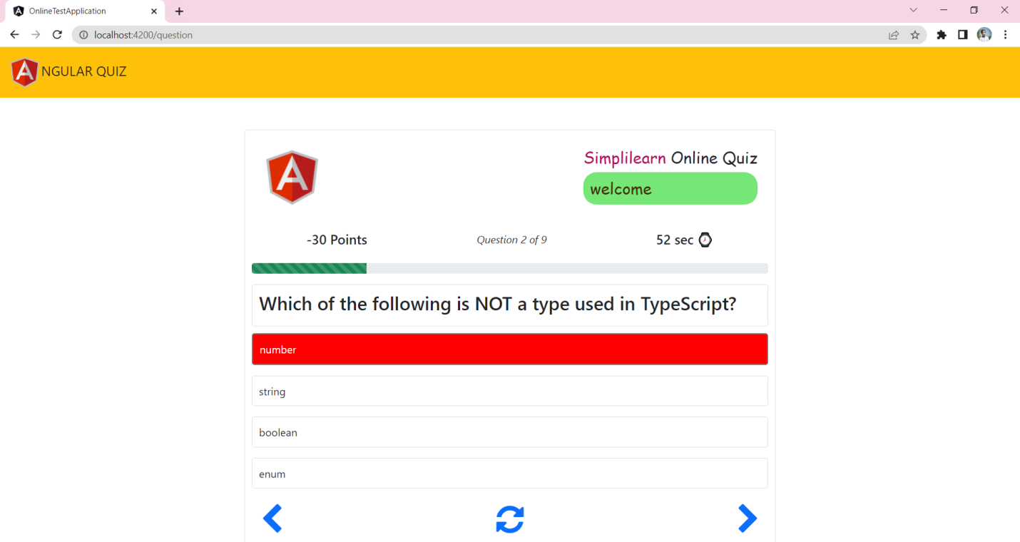

And also decreases 10 points



In 60 sec if you don’t attend the question it will show next question..

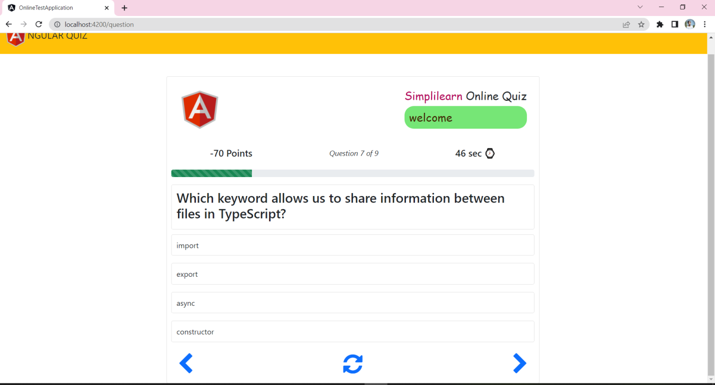

On click left arrow the page shows previous question.

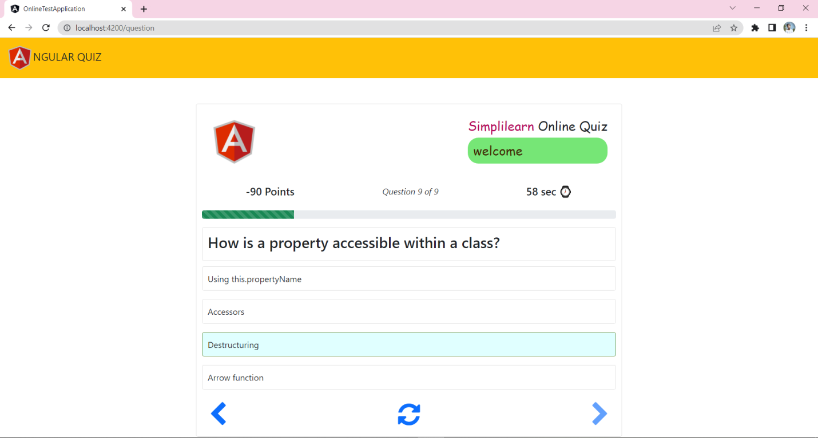



On click right arrow the page shows next

Question.

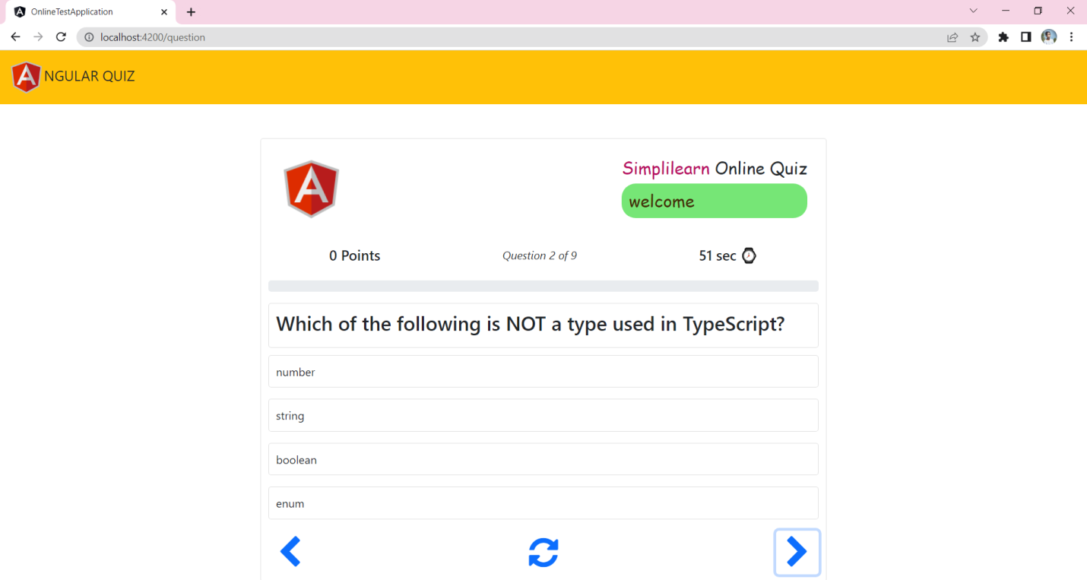

On click the middle button all questions, time and points reset

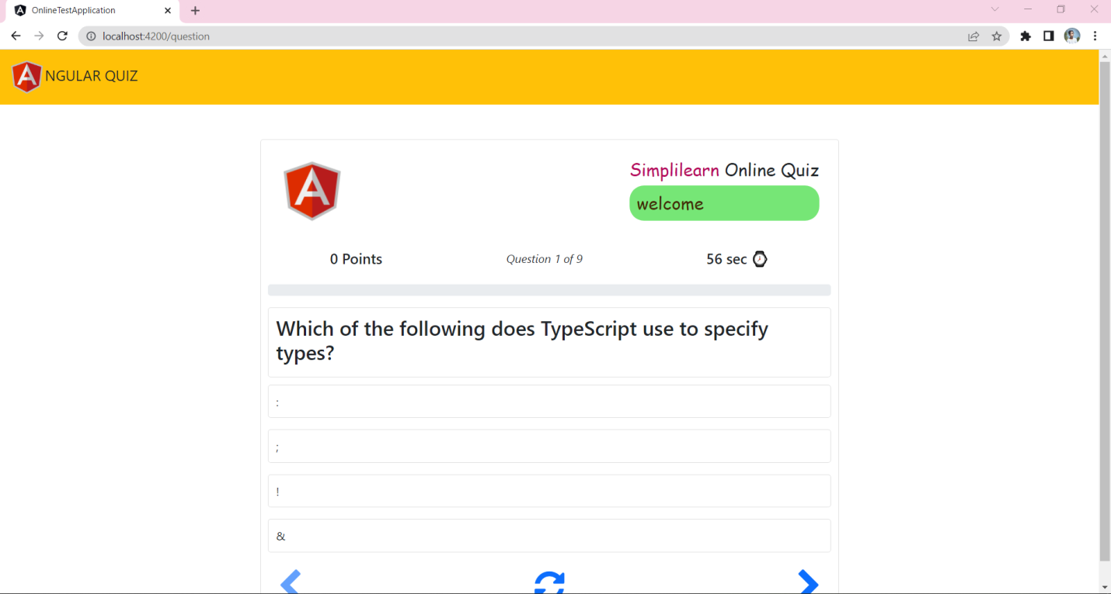



On complete the quiz it shows the result with total correct and incorrect answer with your name.

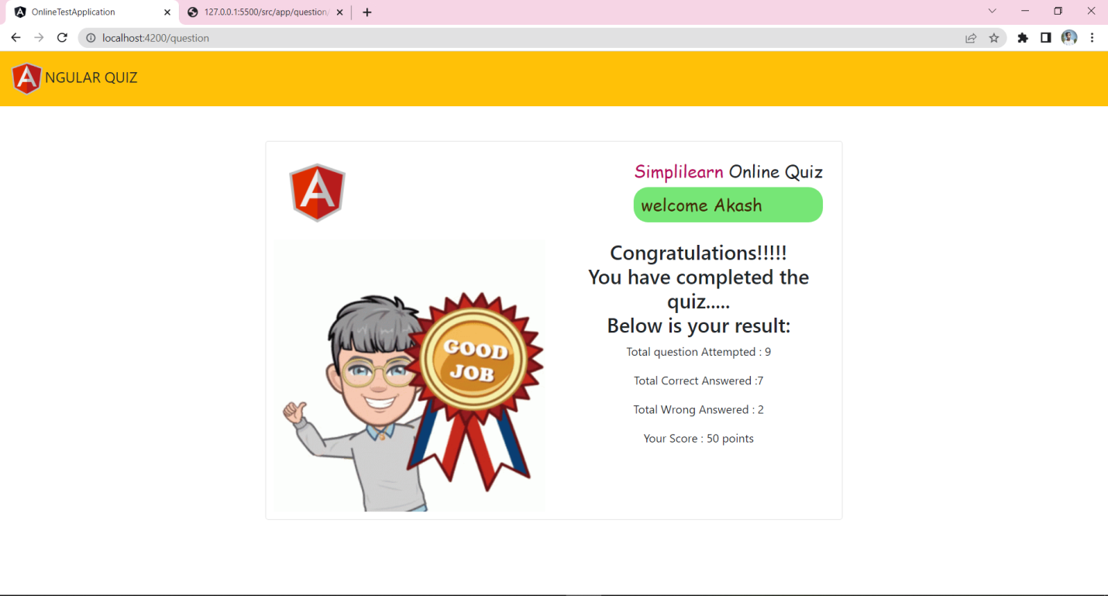

Name: Snehal Mankar